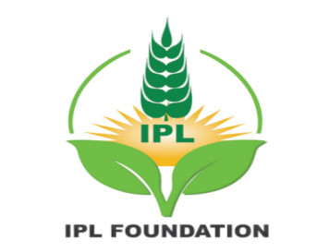 | INTERNS ORIENTATION PROGRAMME  REPORT | 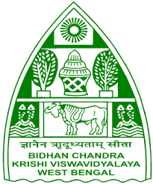
AMRIT INTERNSHIP PROGRAMME
IPL FOUNDATION

Sponsored by
IPL Foundation, New Delhi
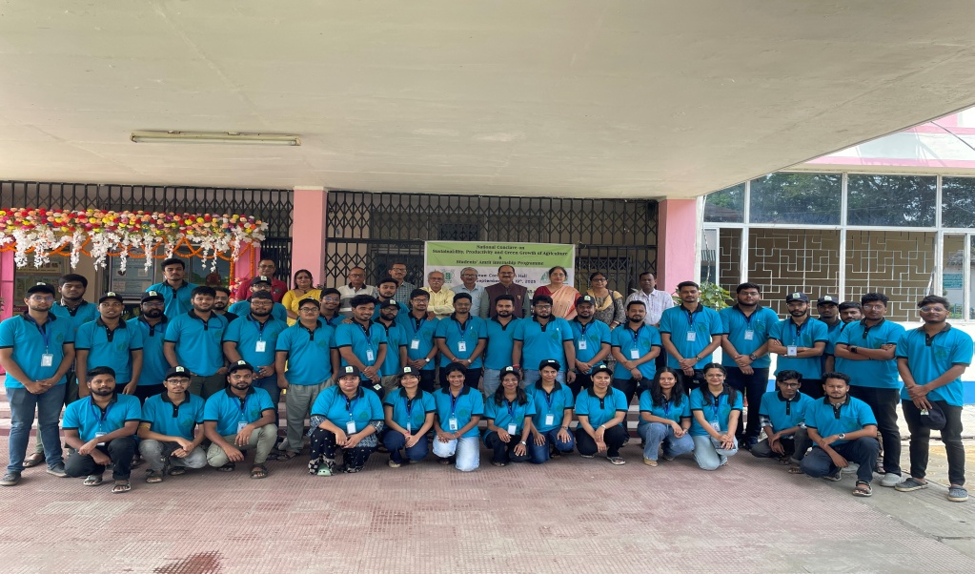

Organized by
Directorate of Extension Education
BIDHAN CHANDRA KRISHI VISWAVIDYALAYA
Nadia, Mohanpur, W.B. PIN-741252

Report of Orientation Programme of Students’ Amrit Internship Programme, sponsored by IPL Foundation, New Delhiand organized by Bidhan Chandra KrishiViswavidyalaya, Mohanpur,
West Bengal held on 19thSeptember, 2025

The orientation of IPL Foundation Students’ Amrit Internship Programme was held on 19th September, 2025 at the Bidhan Chandra Krishi Viswavidyalaya (BCKV) in West Bengal. The programme is funded by IPL Foundation, New Delhi and organized by BCKV, W.B. The chief guest of the orientation program was Hon’ble Vice-Chancellor, Dr. Ashok K. Patra. It is the part of the foundation's corporate social responsibility (CSR) initiative to promote sustainable practices and empower rural communities.
Objectives of the Internship Program
- To equip the interns with clear vision about the rural community.
- To familiarize the interns with the various developmental agencies like PACs/ FPOs/ KVKs, their approaches and strategies and major programmesof agricultural and community development.
- To facilitate the transfer of knowledge on the latest crop technologies tofarmers and support them in practical implementation.
- To raise awareness among farmers about government schemes and assist them in accessing and utilizing the benefits
- To Encourage balanced use of fertilizers
- To familiarize the interns and farmers to integrate modern agriculturaltechnologies to improve productivity, decision-making, and resourcemanagement by using apps.
- To provide interns an opportunity to become familiar with reference toagricultural development emphasizing entrepreneurial skills for creatingscalable, sustainable and innovative agricultural businesses in rural settings.
- To develop skills in interns for solving problems related to agriculture and toprepare development projects/ programmes.
The inaugural session of Students’ Amrit Internship Programme, was held at Bidhan Chandra Krishi Viswavidyalaya (BCKV), Mohanpur, on 19th September 2025. This programme was organized on second day of Two-day National Conclave on “Sustainability, Productivity and Green Growth of Agriculture” sponsored by IPL Foundation, New Delhiand organized by Bidhan Chandra Krishi Viswavidyalaya, Mohanpur,West Bengal held on 18th -19th September, 2025.
On the second day, a student workshop was organized with 50 participants of the IPL Students’ Amrit Internship Programme, BCKV Centre,W.B.
The programme was organized under the leadership of Dr. S. B. Goswami, Director of Extension Education, and Dr. S. C. Kole, Head, Department of Soil Science & Agricultural Chemistry, BCKV. The anchors were Dr. Soma Biswas. (Coordinator, IPL Amrit Internship programme, BCKV Centre) and Dr. Kanu Murmu (Associate Coordinator, IPL Amrit Internship Programme, BCKV Centre).The second day programme includes multiple technical sessions, where experts deliberated on diverse aspects of sustainability, productivity enhancement, climate change adaptation, resource conservation, productivity and green growth in agriculture.
At first, The Coordinator and Associate Coordinator welcome all the interns and the distinguished personalities on the Dias.
The name of distinguished and esteemed personalities whose presence on Dias and addressing speech enriched the programme in all aspects are as follows:
Sl. No. | Name | Designation
1 | Dr. Ashok Kumar Patra | Hon’ble Vice-Chancellor of BCKV, W.B.
2 | Prof. S. K. Acharya | Dean (PG Studies).BCKV, W.B.
3 | Ms. Nandini Roy | Mentor, IPL foundation ,Kolkata
4 | Shri Nilanjan Sinha | Regional Director, NCDC.
5 | Shri Govinda Chandra Das | Principal, CCM, Barsul
6 | Dr. Mahadeb Pramanik | Professor, Dept. of Agronomy, BCKV.
7 | Dr. S.C. Koley | Professor, Dept. of Soil Science, BCKV.

Prof. S. K. Acharya, Dean (PG Studies), in his welcome address, welcomed all the interns and dignitaries present on Dias. Then he highlighted the present scenario of Agriculture and allied sectors related to production, productivity and climate change. He also motivated the interns to do their level best for the betterment of rural community.
In his address, Hon’ble Vice-Chancellor, Dr. Ashok K. Patra, thanked the IPL Foundation for its support in creating this significant platform. He stressed the pressing impacts of climate change on Indian agriculture. He also gave important massage to interns to do their internship responsibilities with sincerity; he emphasized integrated approaches to soil, crop, and environmental sustainability for a greener future.
Sri Nilanjan Sinha discussed about the different role and activities performed by the NCDC. He guided the students about how to approach for the financial assistance from the Cooperative bank.
Sri Govinda Chandra Das shared his experience about cooperative formation and entrepreneurship development. He also highlighted the emerging trend of Start up initiative in agriculture and allied sector.
Dr. Mahadeb Pramanik guided the interns about organic farming. He pointed out the importance and use of organic inputs for soil health as well as human health management.
Mrs. Nandini Roy, Mentor, IPL,explained the objectives of the internship program and its role in promoting sustainability in farmers’ fields; She guided the interns about questionnaire to be filled by the interns with active interaction with respondent farmers. Then she gave hands on training about how to upload the survey data in the IPL google sheet online. She discussed about the E-learning Module.
The T shirts and Caps with IPL logo were distributed among interns. At the end of the orientation programme a formal group photograph with all interns and dignitaries were taken by the organiser.
At the end of the orientation programme Prof. S. C. Kole, Head, Dept of Soil Science, BCKV, proposed the vote of thanks.
Photographs of the event
Students’ Amrit Internship Programme at BCKV

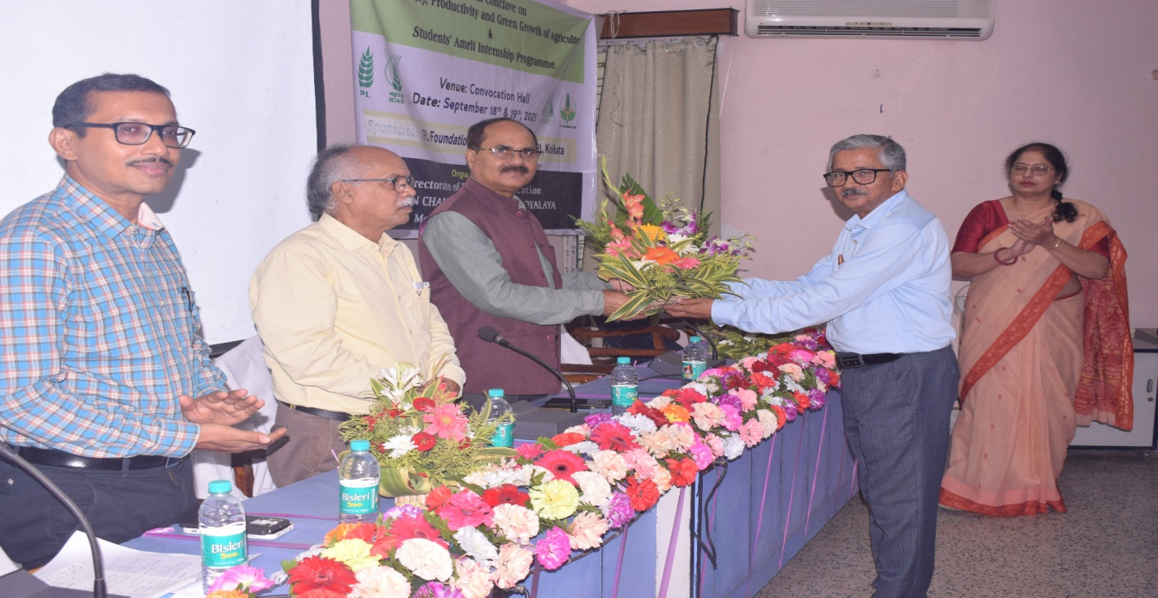

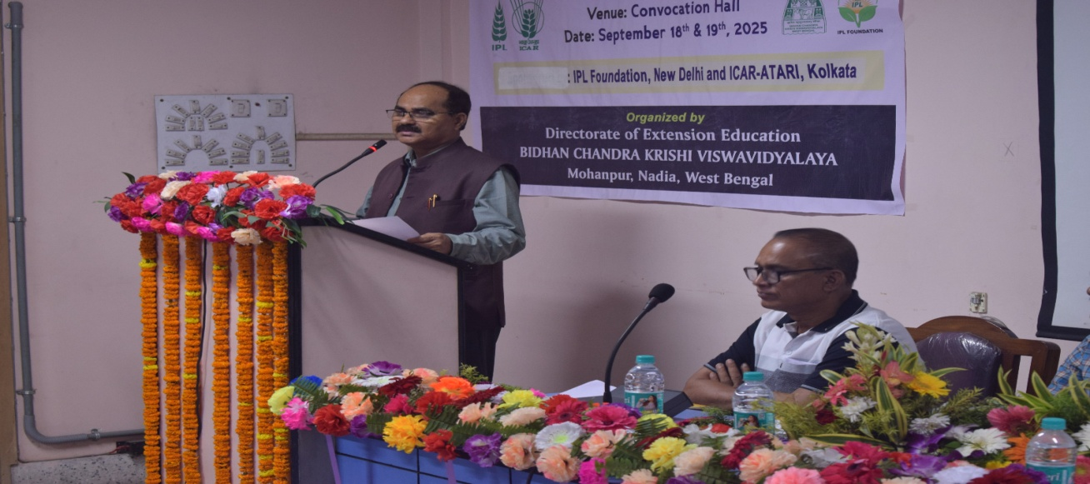
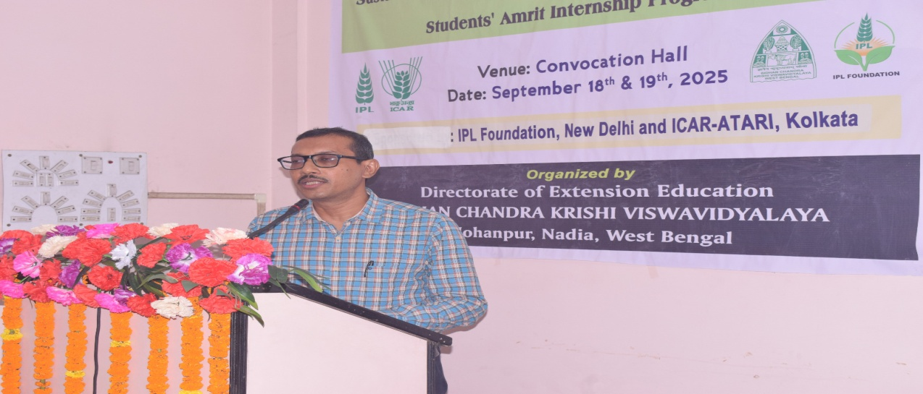
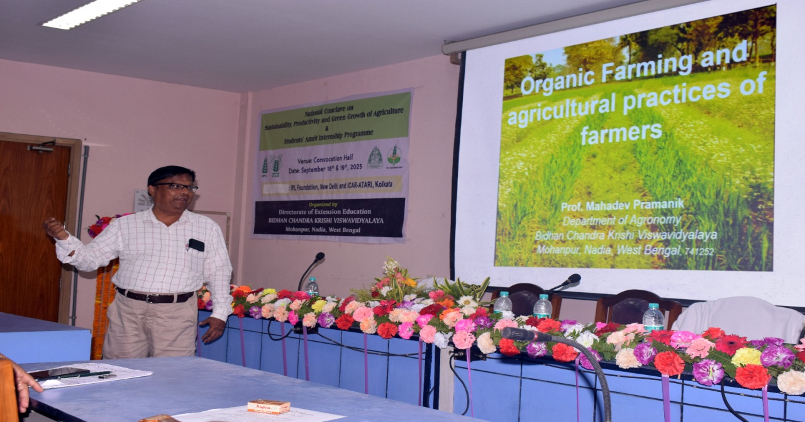
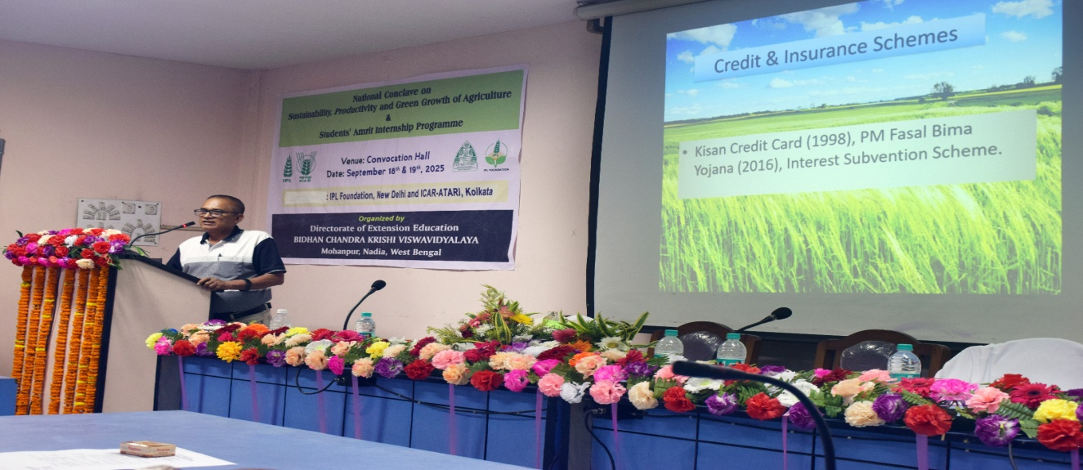
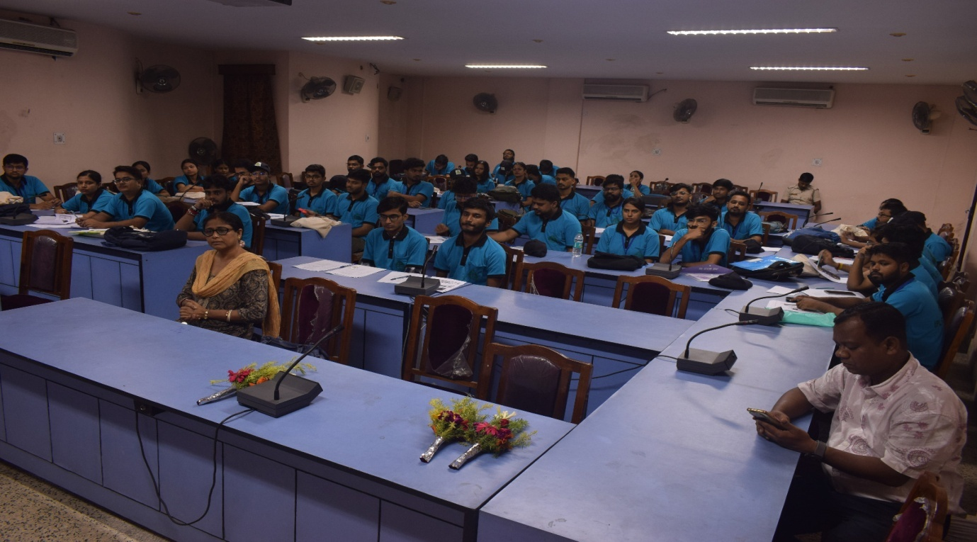
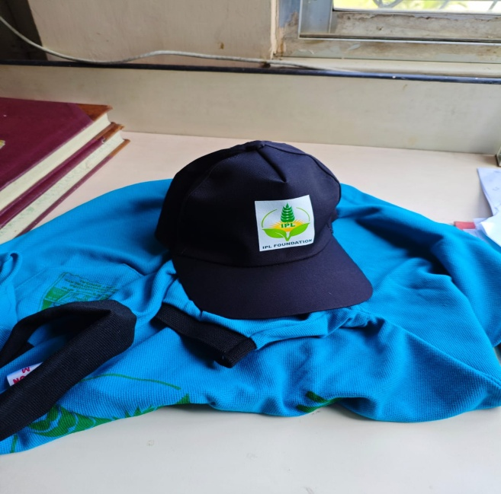 | 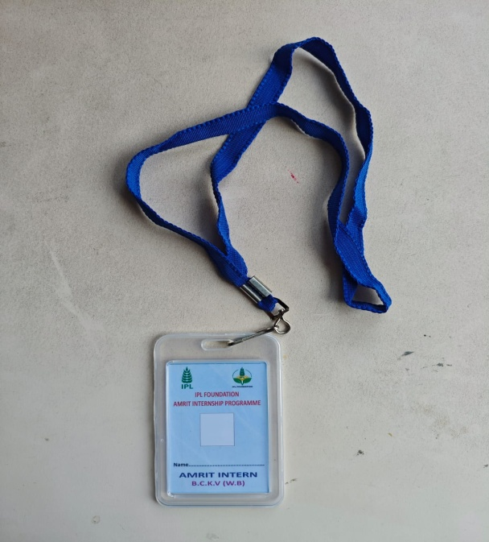
 | 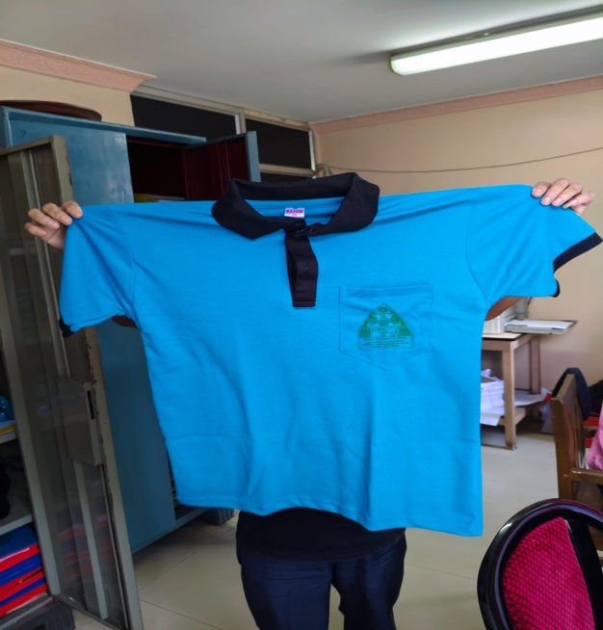
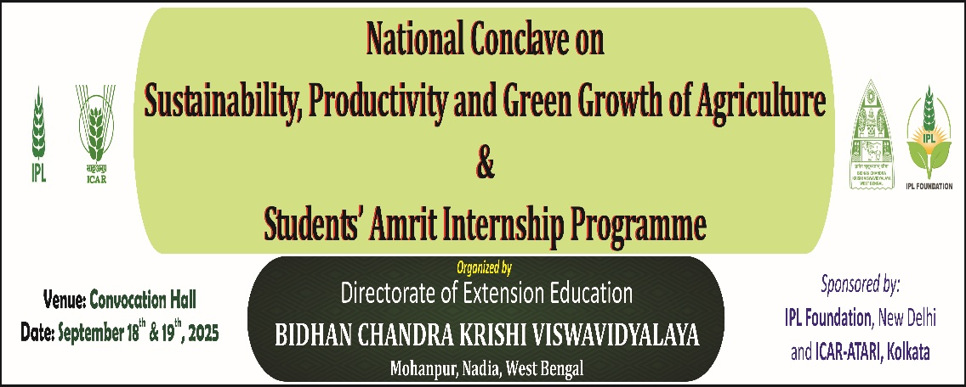

IPL FOUNDATION
AMRIT INTERNSHIP PROGRAMME
Orientation Programme for Amrit Interns
On 19th September,2025
Bidhan Chandra KrishiViswavidyalaya
Mohanpur, Nadia, WestBengal

Programme Schedule

Date:19.09.2025 | Venue: DEE Building Seminar Room (Ground Floor), BCKV
Time | Programme
09:30 – 11:00 | Registration of Interns and Breakfast
11.00 – 12.00 | Inaugural Session
 | Welcome Address: Prof. SubhenduBikashGoswami, Director, Extension Education, BCKV
 | Address by Prof. S.K.Acharya, Dean, Post Graduate Studies
 | Address by Dr. Rajeev Ranjan, Retired IAS, Senior Advisor, IPL Foundation
 | Address by Dr. Ashok K Patra, Hon’ble Vice Chancellor, BCKV
Technical Session:
 | Programme | Speakers
12.30 – 12.45 | Session on “Cooperatives and Farmer Producer Organisations (FPOs)” | ShriNilanjanSinha, RD, NCDC, Kolkata
12.45 – 13.00 | Session on “Organic Farming and Agricultural Practices of Farmers” | Prof. MahadebPramanick, BCKV
13.00 – 13.15 | Lunch Break
13.15 – 14.00 | Session on “Agriculture Programmes and Policies” | ShriGobinda Chandra Das, Principal, CCM, Barsul
14.15 – 15.30 | Hands-on Session on Filling Questionnaires and E-learning Module (Q & A Session) | Mrs. Nandini Roy, Mentor, IPL Foundation
16.50– 17.00 | Vote of Thanks | Dr.Subhas Ch. Kole


Date: 09/10/2025
Director of Extension Education
BCKV, Mohanpur

