Program Report
Orientation Program

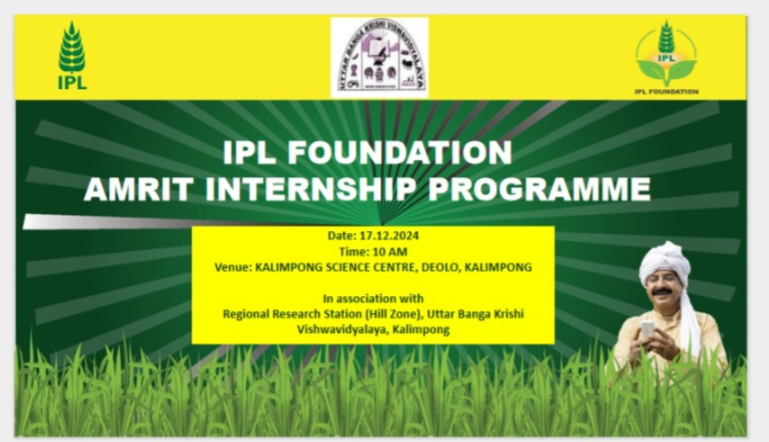
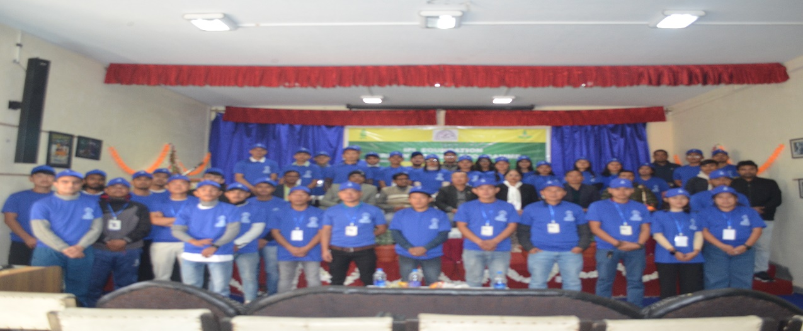
Dr. Biswajit Patra (Coordinator)

Regional Research Station (Hill Zone), Uttar Banga Krishi Viswavidyalaya, Kalimpong

Executive summery
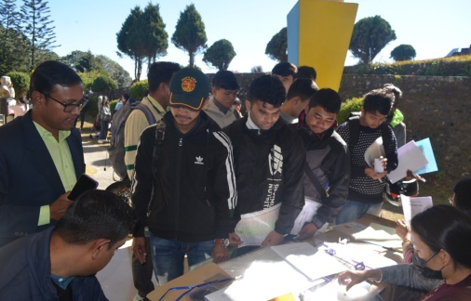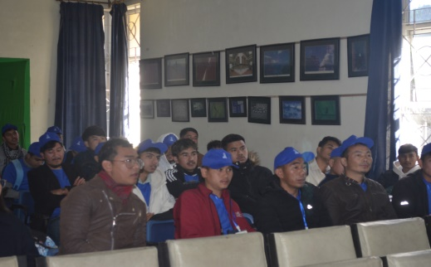
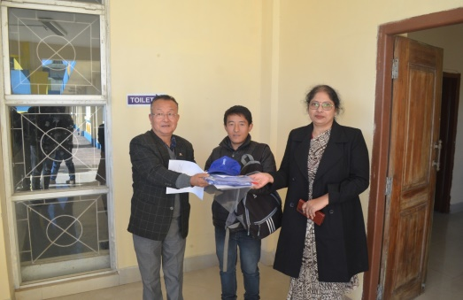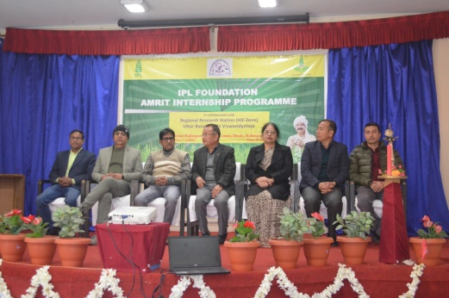
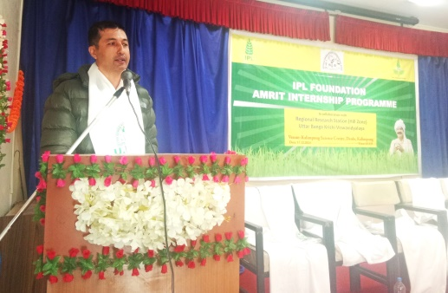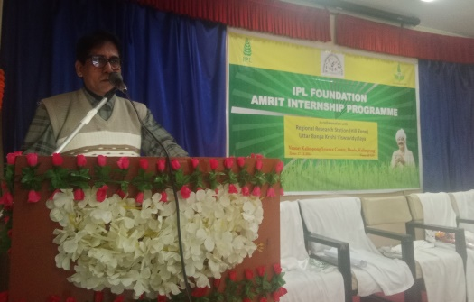

Prologue
Prologue Agriculture remains the backbone of rural India, shaping the livelihoods of millions and serving as a critical pillar of the nation's economy. Yet, challenges such as low productivity, outdated farming practices, and limited access to resources persist, hindering sustainable development. The objective of the IPL Foundation Amrit Internship Program is to sensitise students and farmers to understand existing challenges and possible solutions to improve productivity in a sustainable manner. The purpose of the orientation program is to equip student interns with the knowledge, skills, and sensitivity required to engage meaningfully with rural farmers. By focusing on agricultural productivity with Good Agricultural Practices (GAP) and empowering interns to conduct impactful surveys, the program seeks to contribute to actionable insights and long-term solutions for enhancing rural prosperity. In this report we present the details of the orientation program conducted on 17th of December, 2024.

Introduction
The orientation program of the IPL Foundation Amrit Internship for Kalimpong district, West Bengal, was scheduled on the 17th of December, 2024, at the Kalimpong Science Centre, Kalimpong. Before we proceed in the report, we must briefly state the background of the program. The project of the Internship Program started with the mutual consent between IPL Foundation, under whose banner and funding the program will be implemented, and Regional Research Station (Hill Zone), Uttar Banga Krishi Viswayidyalaya, Kalimpong, West Bengal, as the Implementing Agency. The entire project started with the recruitment of interns from different colleges across different blocks of the Kalimpong district. We have recruited a total of 57 interns, of whom 50 interns finally registered in the Orientation Program. The core objective of the program was to equip interns with an understanding of the key challenges faced by rural farmers, including low productivity, resource constraints, and socioeconomic factors. We have designed the orientation program in such a way that, along with the basic knowledge of the subject matter, interns will develop survey skills, build cultural sensitivity, enhance communication skills, learn cooperative approaches, familiarize themselves with tools and technologies related to farming, manage expectations about the program, and, moreover, understand the broader goal of the internship program. The esteemed resource persons highlighted different facets of the program throughout the day. In this brief report we first present the program schedule. The day started with the offline registration. Following this registration procedure, the formal program started with the lighting of the lamp ceremony in the presence of all the dignitaries. Following this, the welcome address was given by Dr. Sarad Gurung, In-Charge, Regional Research Station (Hill Zone), Uttar Banga Krishi Viswayidyalaya, Kalimpong. Dr. Rajeev Ranjan, Senior Advisor, IPL Foundation, joined the program online and graced the occasion. Mrs. Nanadini Roy, Mentor, IPL Foundation, delivered her speech on the overall objective of the program. Following this, our resource person Dr. B.R. Sharma, Professor in Plant Pathology, Regional Research Station (Hill Zone), UBKV, Kalimpong delivered the lecture on common diseases of field and commercial crops in Hill zone of West Bengal. Mr. Sisir Poudyal, District Cooperative Education Instructor, Darjeeling, West Bengal was our esteemed speaker. Mr. Sarbeswar Mandal, Deputy Director of Agriculture (WBP), and Project Director, ATMA, Kalimpong District, Department of Agriculture, Govt. of West Bengal talked about various government schemes that farmers can avail until we broke for lunch. After lunch Dr. Biswajit Patra, Assistant Professor (Agril. Entomology) Regional Research Station (Hill Zone), UBKV, Kalimpong, and the co-ordinator of the programme talked on Insect Pest scenario of important field crops in Hill Zone of West Bengal. The Valedictory session was chaired by Programme co-ordinator as well as by the mentor IPL Foundation on the different issues of registration, survey, and questionnaire. The program ended with the formal vote of thanks.

IPL FOUNDATION ORIENTATION PROGRAMME FOR AMRIT INTERN
17TH DECEMBER, 2024
Date/Time | 17.12.2024
10:00 AM-10:30 AM | Registration of Interns and ‘High tea’.
10:30AM-10:45 AM | Welcoming the guests of the programme.
10:45AM-11:00AM | Lighting of Lamp by Hon’ble Chief guest, Mr. Sarbeswar Mandal, Deputy Director of Agriculture (WBP), and Project Director, ATMA, Kalimpong District, Department of Agriculture, Govt. of West Bengal.
11:00AM-11:10AM | Welcome address by Prof. S. Gurung, In-charge, Regional Research Station  (Hill Zone), UBKV, Kalimpong.
11:10AM-11:30AM | Address by Dr. Rajeev Ranjan, Senior Advisor, IPL foundation, New Delhi.
11:30AM-11:50AM | Address by Dr. U.S. Teotia, Chief Manager (Agril. Science), IPL foundation, New Delhi.
11:50AM-12:20PM | Address by Mrs. Nandini Roy, Mentor, IPL Foundation.
12:20PM-12:30PM | Lecture by Dr. B.R. Sharma, Professor in Plant Pathology, Regional Research Station (Hill Zone), UBKV, Kalimpong on ‘Common diseases of field /commercial crops in Hill zone of West Bengal.
12:30 PM-12:40PM | Lecture by Mr. Sisir Poudyel, District Cooperative Education Instructor, Darjeeling, West Bengal.
12:40PM-1:00PM | Key Note address by Mr. Sarbeswar Mandal, Deputy Director of Agriculture (WBP), and Project Director, ATMA, Kalimpong District, Department of Agriculture, Govt. of West Bengal.
1:00PM-2:00PM | LUNCH
2:00PM:2:10PM | Lecture by Dr. Biswajit Patra, Assistant Professor (Agril. Entomology)  Regional Research Station (Hill Zone), UBKV, Kalimpong, on Insect Pest scenario of important field crops in Hill Zone of West Bengal.
2:10PM-2:45PM | Question answer session
2:45PM-3:00PM | Valedictory session
3:00PM-3:30PM | Vote of thanks by Dr. Biswajit Patra, Assistant Professor (Agril. Entomology) Regional Research Station (Hill Zone), UBKV, Kalimpong and Programme Co-ordinator.
VENUE: KALIMPONG SCIENCE CENTRE, KALIMPONG

Registration of Interns:
The program started on time with interns’ offline registration. This time slot for registration was about one hour. Mrs. Nandini Roy, Mentor, IPL Foundation and Prof. S. Gurung, In-charge, Regional Research Station (Hill Zone), UBKV, Kalimpong, facilitated the inters in their registration process and also distributed the internship kits. All students were individually attended to complete the registration process successfully.
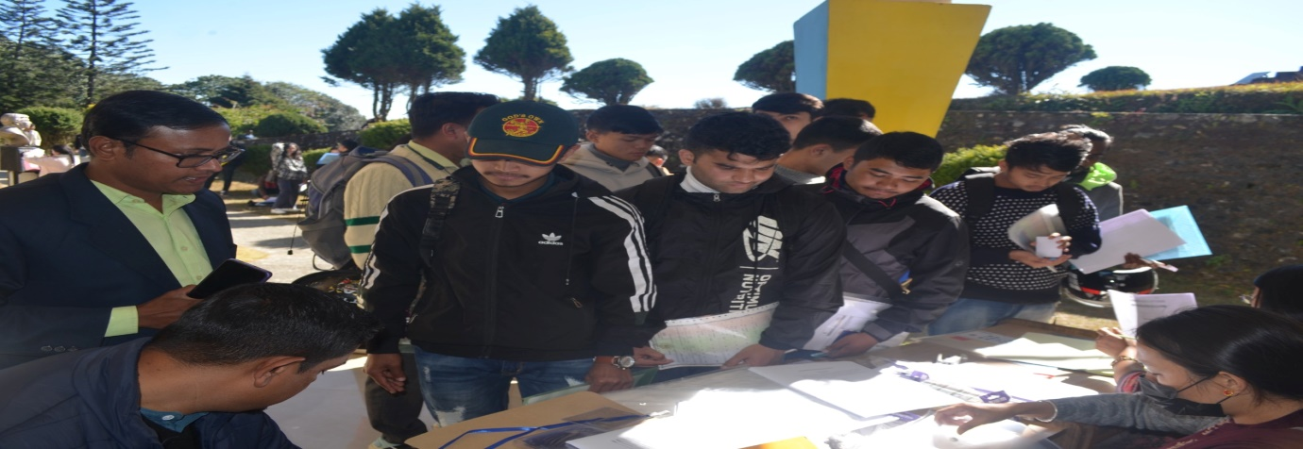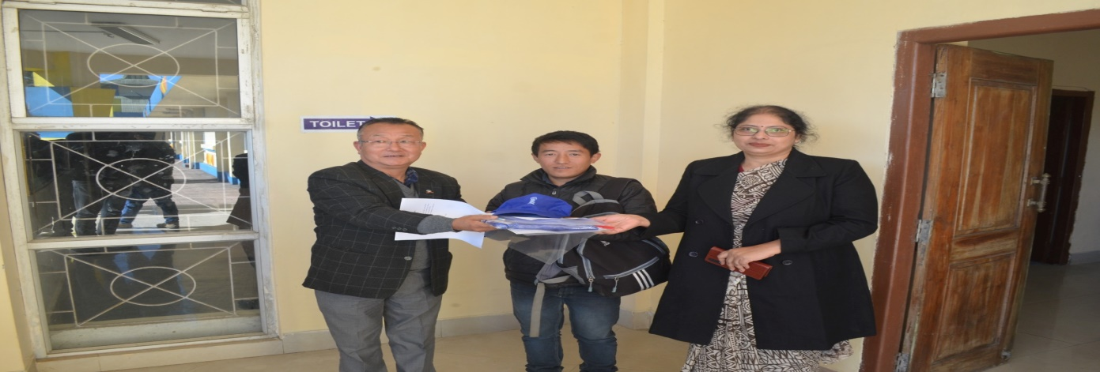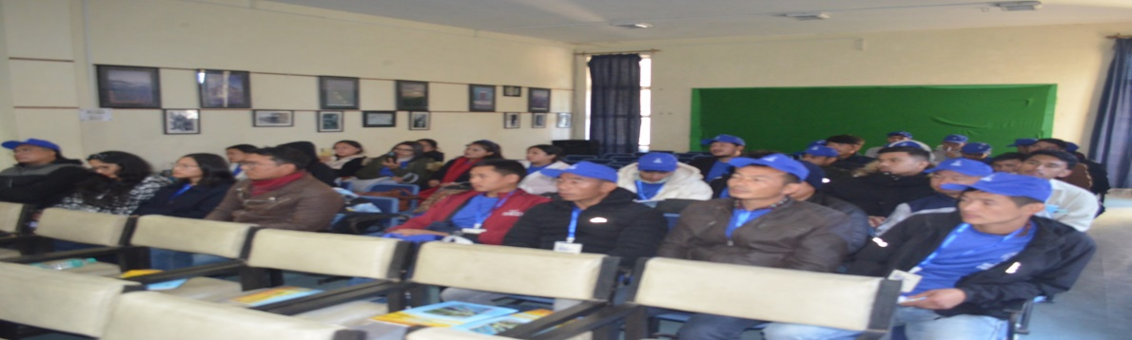
Photo 1: Attendance at the registration desk, offline registration and kit distribution.
Inaugural Program:
Inaugural program started with the felicitation of the dignitaries on the dais followed by the lighting of the lamp ceremony. After that Dr. Sarad Gurung delivered the welcome address. Dr. Sarad Gurung cordially welcomed all the dignitaries and interns wished for a grand success of the programme.
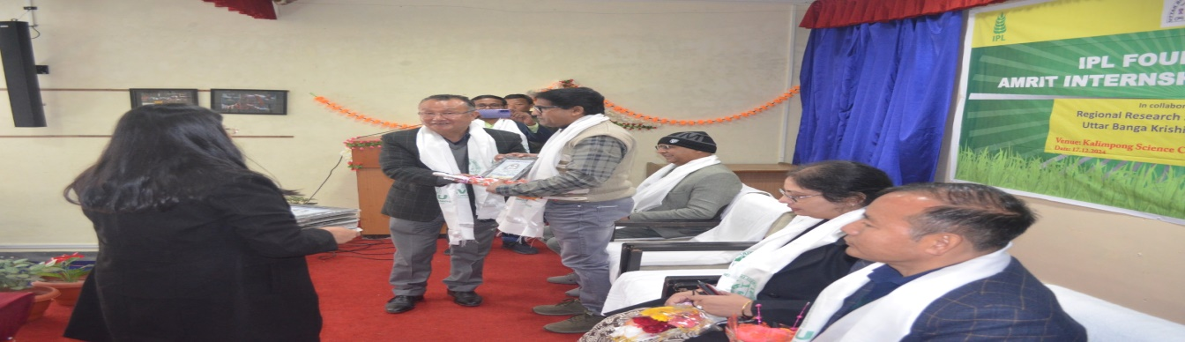

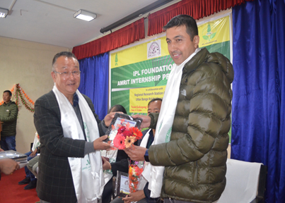Photo 2: Felicitation of dignitaries
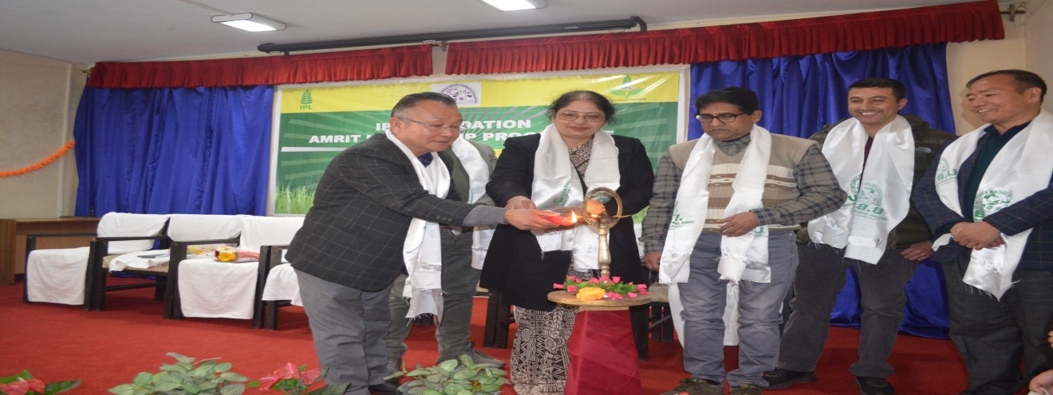Photo 3: Lighting of Lamp Ceremony

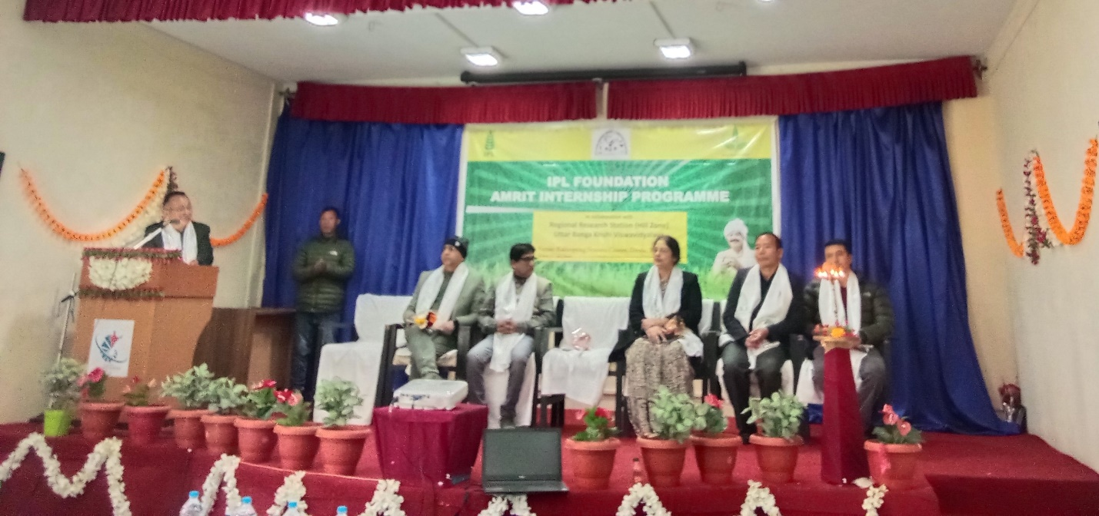Photo 4: Welcome addrerss by Prof. Sarad Gurung, In-charge Regional Research Station (Hill Zone), UBKV, Kalimpong.

After the welcome address by Prof. Sarad Gurung, In-charge Regional Research Station (Hill Zone), UBKV, Kalimpong, Dr. Rajeev Ranjan, Senior Advisor, IPL Foundation graced the occasion joining the program online. Dr. U.S. Teotia was unable to join the programme due to unavoidable circumstances.

Technical Session
The technical session started with lecture from Mrs. Nandini Roy, Mentor, IPL Foundation. Mrs. Roy focused her lecture mainly on different aspects of internship where she covered the objective of the program, expectations from the interns, requirement of ethical standards along with the challenges that they may face during the survey and how to handle the same. She has focused vividly on the learning aspects of internship through different e-learning modules along with the survey work. The session was rich and full of first-hand information which was very useful for the interns.

The next session was delivered by Dr. B.R. Sharma, Professor in Plant Pathology, Regional Research Station (Hill Zone), UBKV, Kalimpong on ‘Common diseases of field /commercial crops in Hill zone of West Bengal. The main topic of the discussion was the identification of diseases and its management especially in hills. In his lecture Dr. Sharma emphasized on production of commercial crops like ginger and large cardamom through good agricultural collection practices. Interns got invaluable insights from his deliberation.
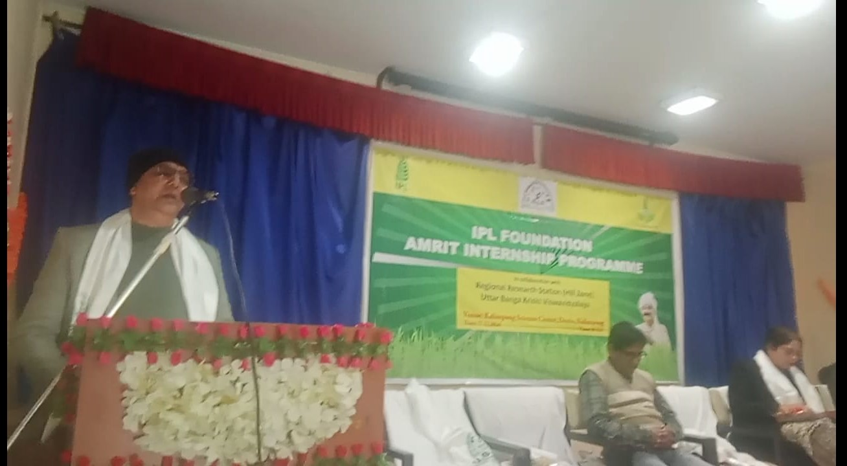Photo 5: Technical session by Dr. B. R. Sharma, Prof. Plant Pathology, Regional Research Station (Hill Zone), UBKV, Kalimpong

The next technical session was conducted by Mr. Sarbeswar Mandal, Deputy Director of Agriculture (WBP), and Project Director, ATMA, Kalimpong District, Department of Agriculture, Govt. of West Bengal. In his lecture of Mr. Mandal discussed about various government schemes related to agriculture and how these schemes will benefit farmers. Most of the farmers are unaware of these government benefits and his lecture will certainly help interns to reach out the farmers and provide guidance to avail such schemes. He also shared multiple cases and success stories of farming at the commercial scale that has motivated all of us.

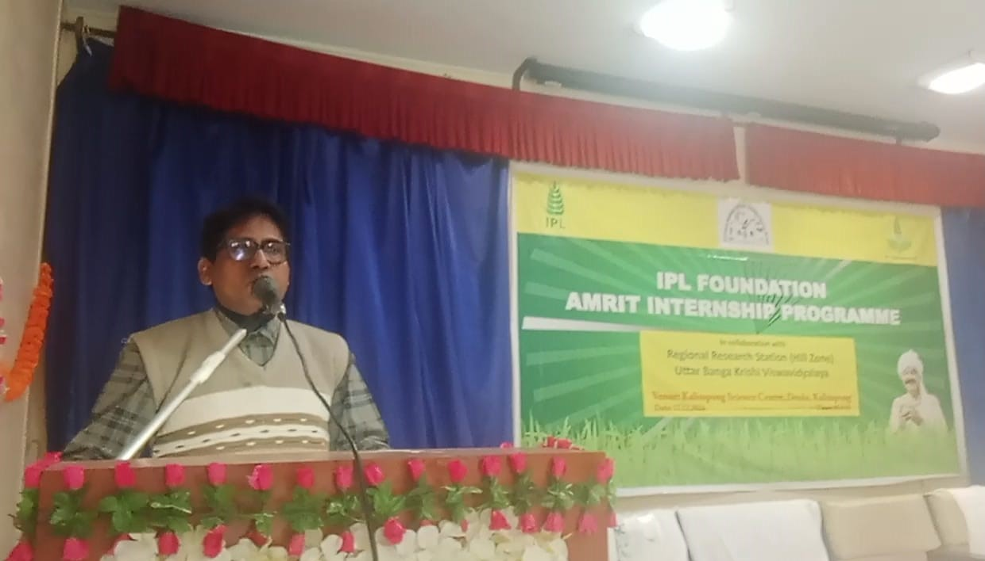Photo 6: Technical session by Mr. Sarbeswar Mandal, Deputy Director of Agriculture (WBP), and Project Director, ATMA, Kalimpong District, Department of Agriculture, Govt. of West Bengal.

The next session was addressed by Mr. Sisir Poudyel, District Cooperative Education Instructor, Darjeeling, West Bengal. His lecture focused on the role of cooperative movement in uplifting livelihood with special emphasis on farmers’ producer organization. He has extended his lecture around multiple aspects of cooperatives, its opportunities and problems and how important this is for the upliftment of the poor.
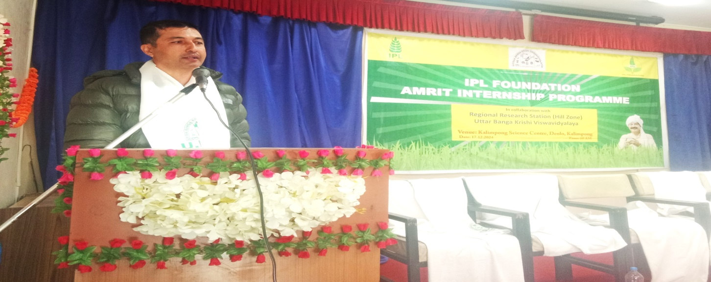Photo 7: Technical session by Mr. Sisir Poudyel, District Cooperative Education Instructor, Darjeeling, West Bengal.
We concluded the technical sessions with the Q&A from the interns followed by the hands on session on registration, using e-learning modules and questionnaire-based survey by Dr. Biswajit Patra, Asst. Prof. Agril. Entomology Regional Research Station (Hill Zone), UBKV, Kalimpong cum Co-ordinator of the program. As the majority of the discussions around questionnaire and how to carry out survey work the final session was mainly on the procedural aspects of the internship. The program of the day ended with the formal vote of thanks to the dignitaries and all the personas associated with the program.
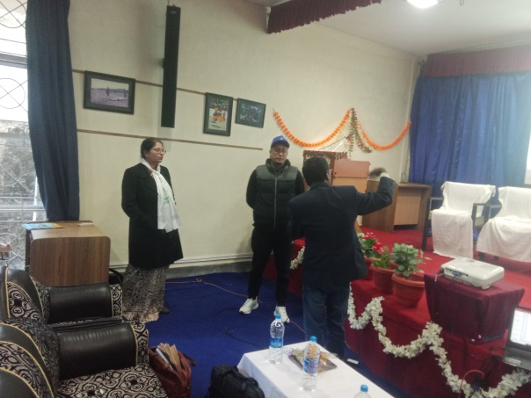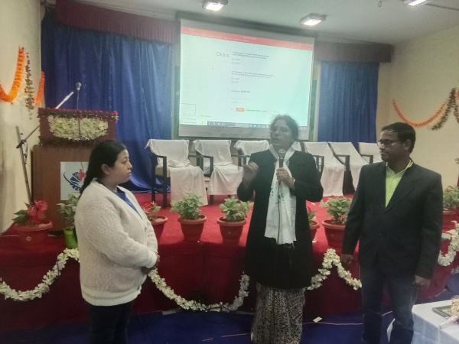
Photo 8: Question and Answer session.

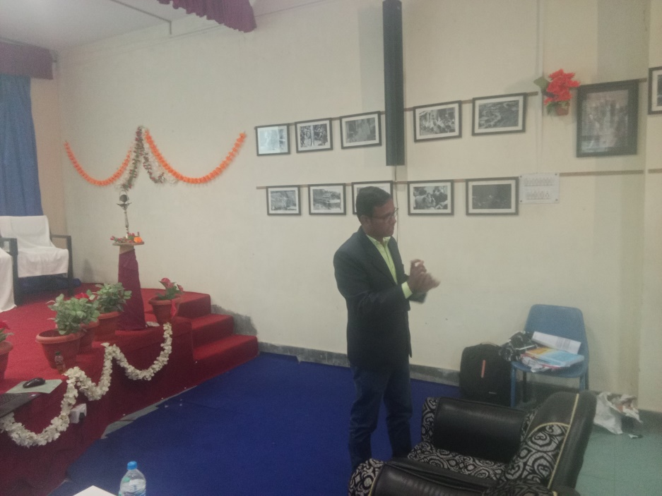
Photo 9: Hands on Training by Dr. Biswajit Patra, Asst. Professor, Agril. Entomology, Regional Research Station (Hill Zone), Kalimpong.

Major Outcomes:
The following outcomes are obtained from the IPL Foundation Amrit Internship orientation program:
- Interns were able to get a concrete idea about the objectives of this internship.
- Interns also got an idea of how to mitigate the challenges they might face while conducting survey in accordance with ethical standards.
- Through this program they got an idea about the various aspects of internship with the help of e-learning modules.
- Through this program, the interns were able to understand the various aspects of agriculture i.e. cropping pattern, soil health, fertilizers, insect pest and diseases, land types, etc. of Kalimpong district.
- They got an idea about the scope and potential of cultivation of different commercial crops in Kalimpong district. They also got inspiration to engage in commercial farming in future.
- The interns got the clear picture about the role of co-operative society for the improvement of agriculture as well as farmers livelihoods.
- The interns get valuable insights into how they could conduct a survey with help of the members of co-operative society.
Brief Overview of District Profile and Interns Concentration
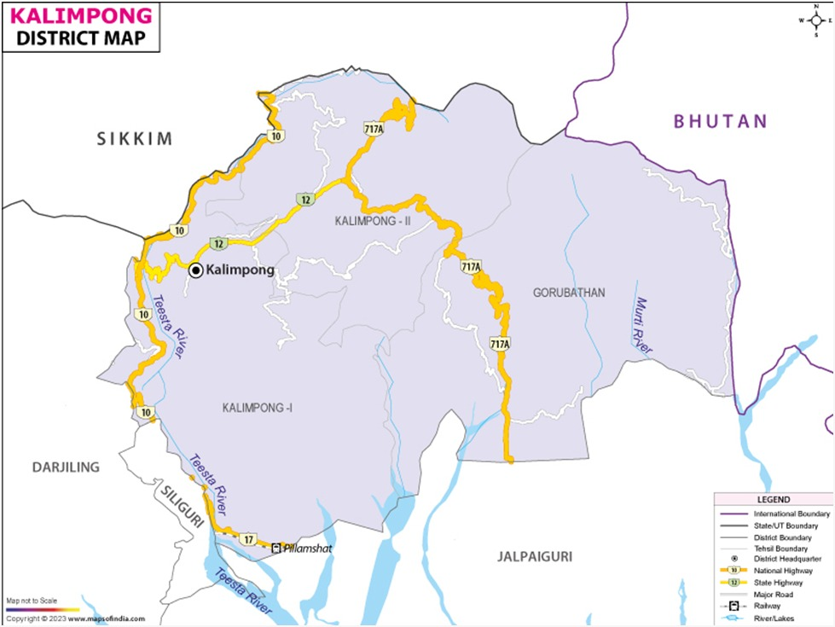
Area of Kalimpong district | 1,053.60 Km²
Population Density (2011) | 2,51,624
Number of Blocks | 4
Major crops | Paddy, Maize, Ginger, Large cardamom, Oranges and Potato.
Number of Blocks covered under survey | 4
Number of Interns | 50
Blocks with High density of interns | Kalimpong-I
Blocks with low density of interns | Gorubathan
Annexure 1

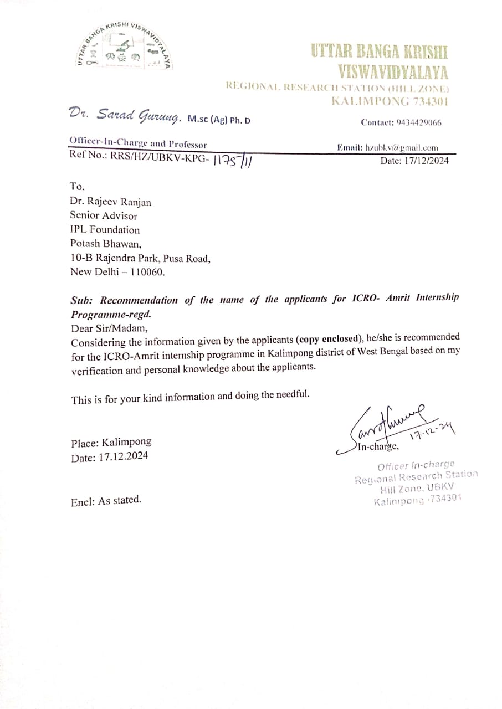

Annexure 2
List of interns, Kalimpong district
Sl no. | Name | Reg. ID | Ph. number | Name of the Board/College/University | Desired block for survey
01 | SHOVARAJ RAI | 20241200349 | 9775473210 | WBCHSE | GORUBATHAN
02 | ABHIJIT CHHETRI | 20241200174 | 6361585697 | WBCHSE | GORUBATHAN
03 | PASSANG DORJEE TAMANG | 20241200183 | 8927824027 | W.B.U.O.G.A.F.S. | KALIMPONG-I
04 | AANCHAL RAI | 20241200153 | 6296464784 | PRESIDENCY UNIVERSITY | KALIMPONG-I
05 | ARATI THAPA | 20241200164 | 9933481612 | NBU | KALIMPONG-I
06 | SUSHMA SUBBA | 20241200190 | 9083847443 | NBU | KALIMPONG-I
07 | SUMINA RAI | 20241200193 | 8207263371 | NBU | KALIMPONG-I
08 | PRATIMA PAKHRIN | 20241200170 | 8388922454 | NBU | KALIMPONG-I
09 | SUSHMITA TAMANG | 20241200186 | 8167403837 | IGNOU | KALIMPONG-I
10 | AMRITA CHHETRI | 20241200185 | 7063303807 | IGNOU | KALIMPONG-I
11 | REWAS CHHETRI | 20241200239 | 8388038077 | WBCHSE | GORUBATHAN
12 | BAR TSHERING LEPCHA | 20241200229 | 7363992077 | IGNOU | KALIMPONG-I
13 | PUKAR RAI | 20241200234 | 9064523720 | NBU | KALIMPONG-II
14 | DIPESH CHHETRI | 20241200242 | 9907260276 | WBCHSE | KALIMPONG-II
15 | RAJEN CHHETRI | 20241200167 | 9339326292 | WBCHSE | KALIMPONG-I
16 | AJAY SUBBA | 20241200230 | 8116206015 | NBU | KALIMPONG-I
17 | SHIVA KUMAR RAI | 20241200176 | 7501082645 | WBCHSE | KALIMPONG-I
18 | PURAN GURUNG | 20241200233 | 7074221993 | NBU | KALIMPONG-I
19 | RAMESH MUKHIA | 20241200236 | 8597625352 | WBCHSE | KALIMPONG-I
20 | RUPEN SUBBA | 20241200238 | 8167843614 | NBU | KALIMPONG-I
21 | GHANASHYAM BHUJEL | 20241200232 | 9641787158 | NBU | KALIMPONG-I
22 | GOURAV SINHA | 20241200182 | 9883551423 | CBSE | KURSEONG
23 | AVINASH SUBBA | 20241200169 | 9883841066 | WBCHSE | KALIMPONG-I
24 | PRAHLAD CHHETRI | 20241200184 | 8967544514 | WBCHSE | KALIMPONG-I
25 | PRAVESH MISHRA | 20241200168 | 7029774570 | WBCHSE | KALIMPONG-I
26 | SWAROOP SHARMA | 20241200165 | 9883371378 | WBCHSE | KALIMPONG-I
27 | NIMESH TIMSINA | 20241200161 | 9800639241 | SIKKIM UNIVERSITY | KALIMPONG-II
28 | SUDHAKAR LAMA | 20241200187 | 8617846075 | UBKV | KALIMPONG-I
29 | BIJOY DAMEN GURUNG | 20241200240 | 8972094763 | SHIATS | KALIMPONG-I
30 | NIKHAL GURUNG | 20241200191 | 9064881280 | THE NEOTIA UNIVERSITY | KALIMPONG-I
31 | PARINA DAHAL | 20241200189 | 8250457223 | NBU | KALIMPONG-I
32 | MALINA RAI | 20241200243 | 9832244889 | NIOS | KALIMPONG-II
33 | MR.KUMAR TAMANG PAKHRIN | 20241200235 | 9932918268 | NBU | KALIMPONG-II
34 | ASHWIN GURUNG | 20241200158 | 9064969795 | THE NEOTIA UNIVERSITY | KALIMPONG-I
35 | SUBHAM THAPA | 20241200254 | 9749456173 | WBCHSE | KALIMPONG-I
36 | JESON LEPCHA | 20241200255 | 8101841536 | WBCHSE | KALIMPONG-I
37 | DIPSHIKA THAPA | 20241200257 | 8392069768 | WBCHSE | KALIMPONG-I
38 | CHALITRA TAMANG | 20241200256 | 9382019871 | NBU | KALIMPONG-I
39 | ISMAEL LEPCHA | 20241200350 | 8967826721 | WBCHSE | KALIMPONG-I
40 | YANKEY DOLMA TAMANG | 20241200317 | 7479142742 | WBCHSE | KALIMPONG-I
41 | SUBARNA RAI | 20241200318 | 8001681173 | WBCHSE | KALIMPONG-I
42 | KINET LEPCHA | 20241200321 | 9734461220 | WBCHSE | KALIMPONG-II
43 | CHHEKI SHERPA | 20241200305 | 9749290218 | NBU | KALIMPONG-II
44 | SALINA TAMANG | 20241200294 | 7501389839 | WBCHSE | KALIMPONG-II
45 | JOSEPH ADEN LEPCHA | 20241200304 | 9800102612 | NBU | KALIMPONG-II
46 | GRACY LEPCHA | 20241200296 | 7602508148 | NIOS | KALIMPONG-II
47 | SHANKAR DHITAL | 20241200320 | 8101076226 | NBU | KALIMPONG-I
48 | RAGYAN LEPCHA | 20241200253 | 7866899780 | NBU | KALIMPONG-II
49 | PRAMILA TAMANG | 20241200356 | 9641820734 | WBCHSE | KALIMPONG-I
50 | MANGAL DAS TAMANG | 20241200357 | 8250115941 | NBU | KALIMPONG-I
51 | DIVYA TAMANG | 20241200354 | 9733374279 | NBU | KALIMPONG-I
52 | LIZAMIT LEPCHA | 20241200319 | 9732335975 | IGNOU | KALIMPONG-I
53 | CHESANG DOLMA TAMANG | 20241200355 | 9593929098 | NBU | KALIMPONG-I
54 | SAROJ RAI | 20241200297 | 9474934296 | WBCHSE | GORUBATHAN
55 | PRAKASH BHUJEL | 20241200353 | 7028460739 | NBU | KALIMPONG-I
56 | SANDIP THAPA | 20241200166 | 8617857164 | NBU | GORUBATHAN
57 | UPDESH LEPCHA | 20241200213 | 9883908537 | NBU | KALIMPONG-I

Annexure 3: Attendance Sheet of Oreantation Program
